WGU C964

Task 2 - Section D

POST IMPLEMENTATION REPORT

Warren Harper

Student ID: 001326657

Date: 07/29/2021

**Project purpose**

To build a self-driving vehicle that is able to navigate a lane and detect objects using machine learning.

**Data sets**

Data set 1: Lane navigation

The left image is the raw format and right is the image after preprocessing (processed in the Colab Jupyter notebook ‘arnie_lane_nav.ipynb’ ). The image is cropped to a resolution of 200 x 66 pixels and converted to the YUV color space. This is optimum size and format for the training the chosen model.

There are 4157 images found in /data/driving_images

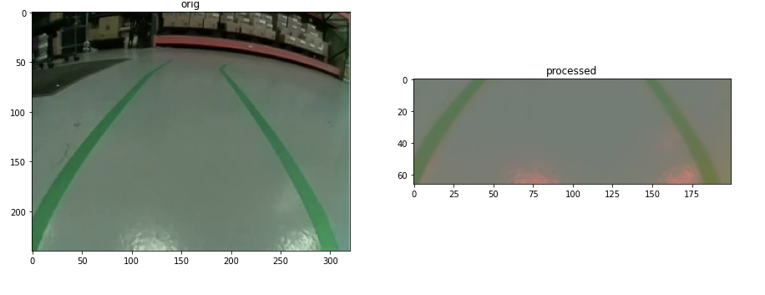

Data set 2: Image detection

These images are used to train the second model to detect these specific objects. The first image is a raw image. The second image is a screen shot of the labelling process. We use the labelling process to generate an xml file that we use to tell our model the boundaries of our object when training.

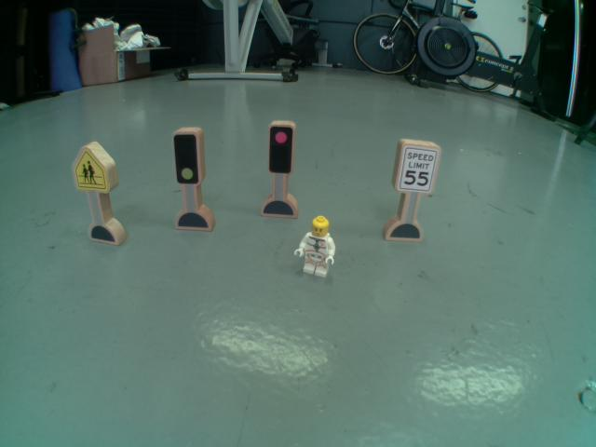

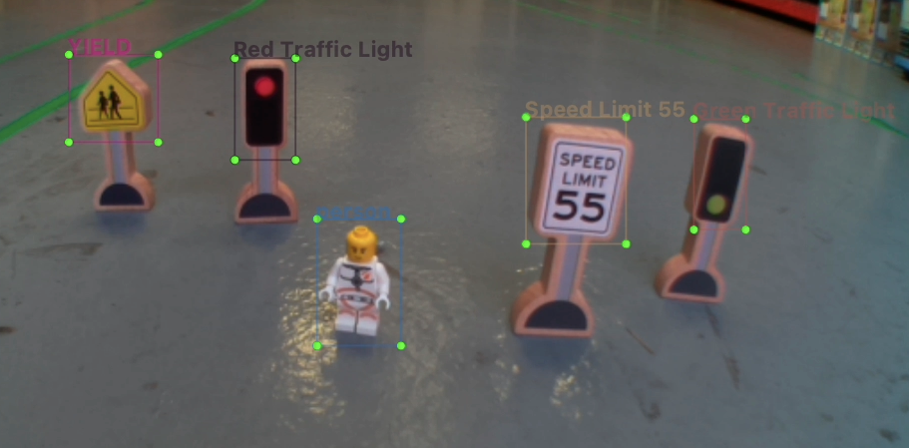

**Data product code**

The root directory consists of 2 Jupyter notebook files that contain the code to prepare our data and subsequent training of the machine learning models.

**arnie_lane_nav.ipynb :** Written in python in a Jupyter notebook (Colab).

This program:

Imports the training images

Processes the images and prepares them for training

Trains and creates a machine learning model

**arnie_sign_detect.ipynb :** Written in python in a Jupyter notebook (Colab). This program:

Imports the training images

Processes the images and prepares them for training

Trains and creates a quantized (required for TPU) machine learning model

Compiles ML model for TPU use

The trained models can be found in **root/models/**

Below is a Tensorboard screenshot showcasing the classification loss decreasing as the object detection model is being trained.

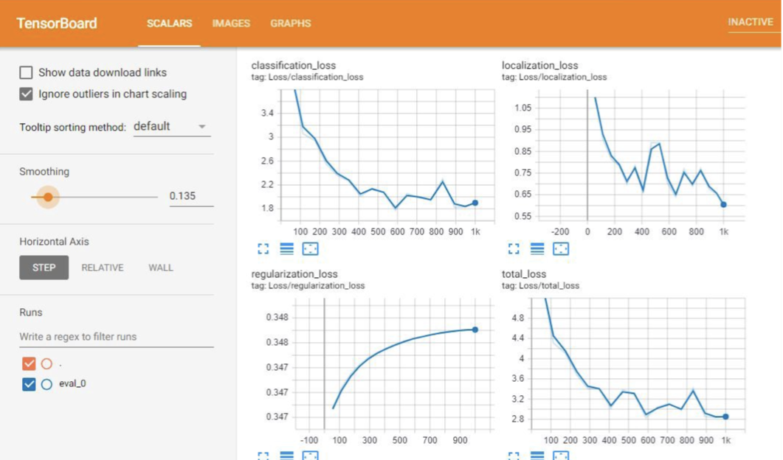

The second screenshot is a matplotlib graph showcasing the training/validation loss decreasing as the navigation model is trained.

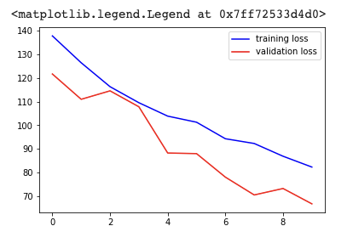

**Hypothesis verification**

The self-driving car (Arnie) successfully accomplished its two primary goals,

1. Navigate an unseen course.

2. Detect predetermined objects and react accordingly.

Please see my video which I have included in my capstone submission. Below are two screenshots showing the unseen course and object detection.

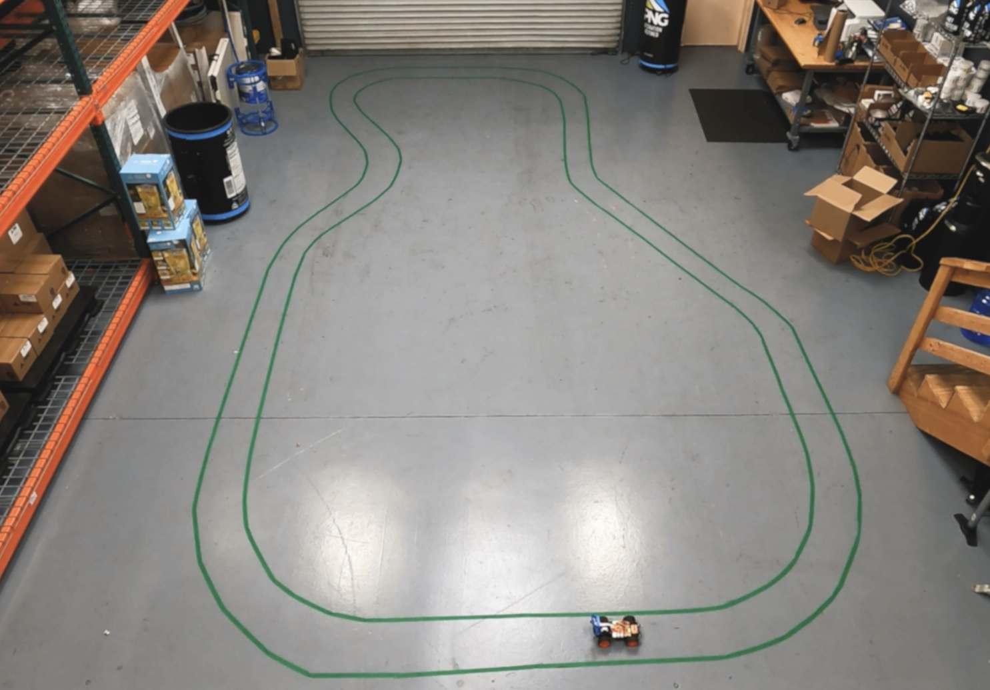

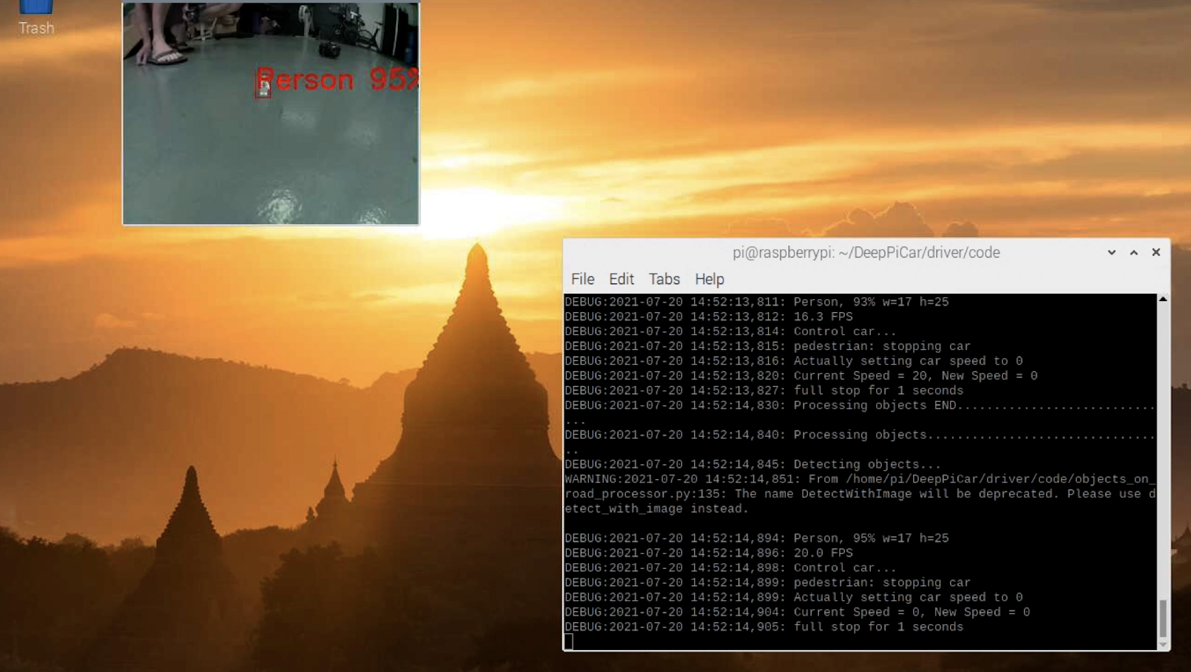

**Effective visualization and reporting**

Below is a graph of the model training process which shows both the training and validation loss converging and lowering, proving that the accuracy of the model is increasing with each training cycle.



**Accuracy analysis**

The accuracy of the lane following function was very high (see video). The only time the car would start to diverge is when the speed was set too high, however, I believe this was more a limitation of the hardware (camera and raspberry pi) and its inability to process the data quick enough.

The object detection model was also highly accurate, successfully detecting each object with an assurance of 90% or above.

Person - 95%

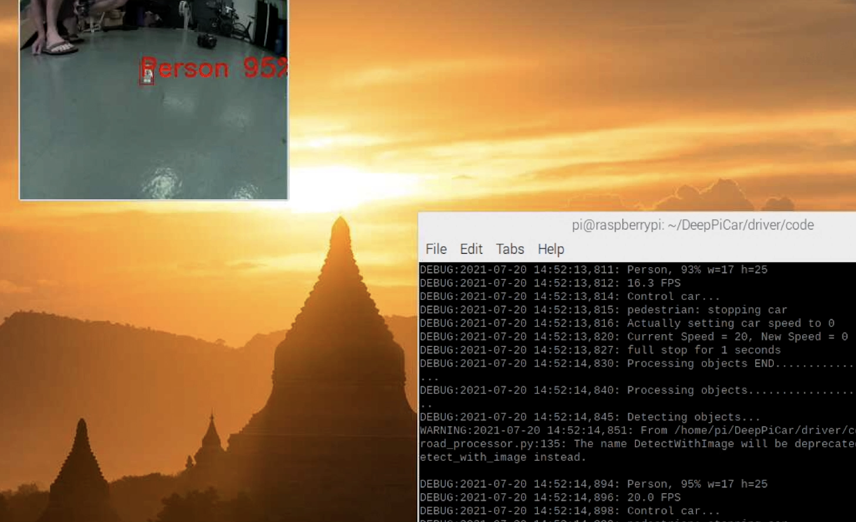

Red light - 100%

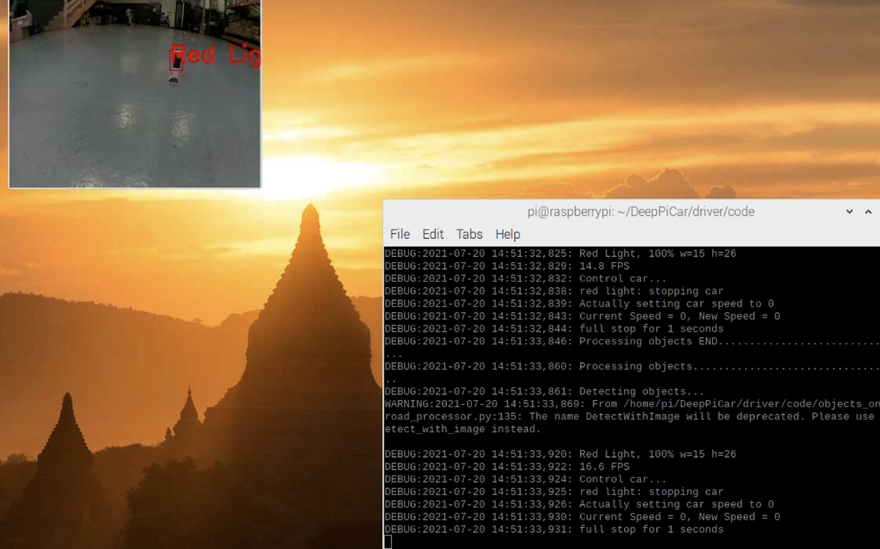

Speed sign - 91%

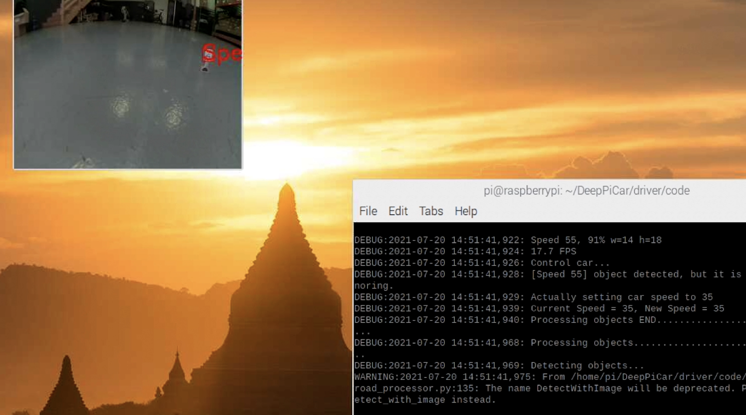

Yield sign - 100%

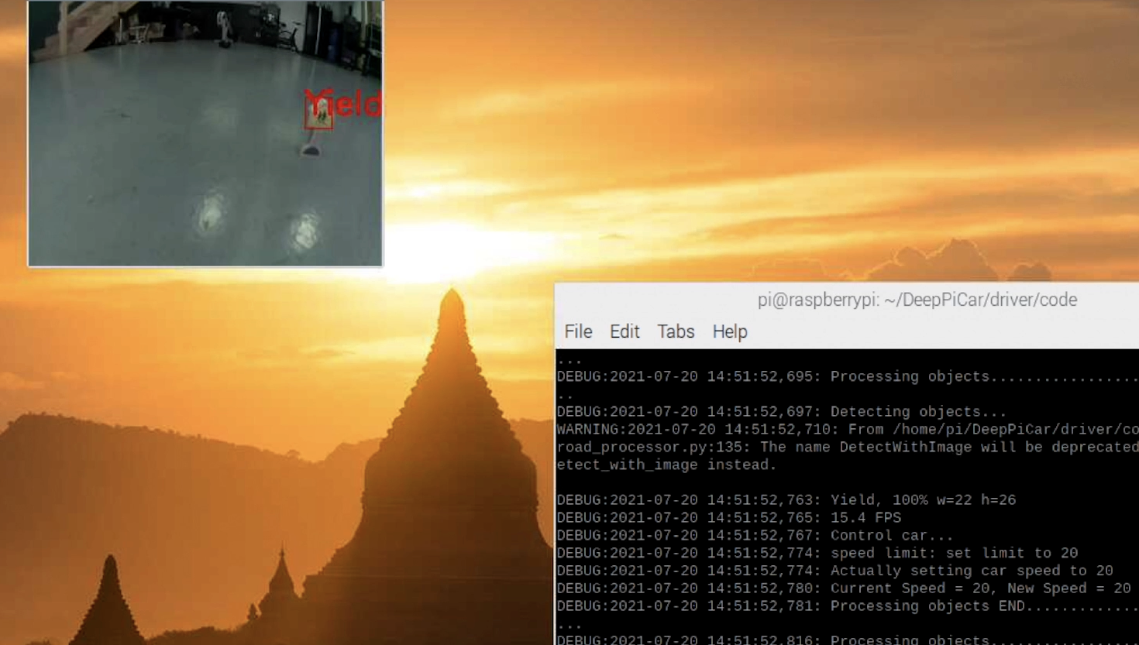

**Application testing**

Testing was focused on the two main objectives, lane detection and object detection. The lane navigation was the most challenging. I discovered early on that there are many factors that really influence the models ability to detect a lane successfully. A good example of this is light. When the light changes, the incoming images change. Controlling for the light helped me to increase the accuracy of the lane detection model without providing training images that account for all manner of light situations. In a real world production situation, we would simply collect training data (images) of lanes in as many light/environmental situations as possible.

Object detection was much more straightforward. The model was able to detect the objects very accurately (90% and above) with only 50 training images. It was able to do this in most environments, much less temperamental than the lane navigation model. The only challenge was getting the model to run quick enough on the raspberry pi. During the initial tests, the raspberry pi cpu could only run the program at 1-2 frames per second. The solution ended up being to implement a dedicated TPU. This was able to run the model at around 15 frames per second.

Due to the nature of the project, no user testing was conducted.

**Application files**

The root directory consists of 9 code files:

**arnie_controller.py :** Written in python to control the car manually and record a series of images and the corresponding steering angle of the car. Executed from the command line, the car is then controlled using ‘WASD’ keys and the program is quit using the ‘q’ key. These images are used to train the machine learning model.

**arnie_lane_nav.ipynb :** Written in python in a Jupyter notebook (Colab).

This program:

Imports the training images

Processes the images and prepares them for training

Trains and creates a machine learning model

**arnie_sign_detect.ipynb :** Written in python in a Jupyter notebook (Colab). This program:

Imports the training images

Processes the images and prepares them for training

Trains and creates a quantized (required for TPU) machine learning model

Compiles ML model for TPU use

**arnie.py :** Written in python to drive the car, executed from the command line. This program takes one argument in the form of a number from 1-3 to select the feature to use.

1 - Lane detection using OpenCV and math (no machine learning)

2 - Lane detection using machine learning. Car will start driving and navigate between the lines.

3 - Object detection using machine learning. Car will start driving and react to the following objects:

1. Person (lego man) - Car will stop
2. Green traffic light - Car will continue
3. Red traffic light - Car will stop
4. 55 Speed limit sign - Car will speed up
5. Yield sign - car will slow down

**detectable_objects.py :** Written in python. This is a class utilized by arnie_sign_detect.py to classify the 5 objects listed above.

**export_image_steering_data.py :** Written in python and executed on the command line. This program takes a video file as an argument and saves it out as a series of images and the corresponding steering angle, calculated using the lane_follow.py program. The images are used to train the lane-following machine learning model.

**lane_follow.py :** Written in python. This is a class that the main driver program (arnie.py) uses to navigate a lane using edge detection (OpenCV) through the onboard camera and then calculating a heading based on those edges.

**lane_follow_ml.py :** Written in python. This is a class used by the main driver program (arnie.py) to navigate a lane using machine learning.

**object_detection_processor.py :** Written in python. This is a class used by the main driver program (arnie.py) to detect objects. This program also provides the logic (what the car needs to do) for each object.

**Users guide**

The entire code directory including the models need to be copied to a compatible car which utilizes a raspberry pi running NOOBS Raspbian Operating System. This car needs to be a Sunfounder PiCar as the programs use the Sunfounder API in order to control the hardware.

The car needs to have Python 3.x and Tensorflow 2.0 installed. Note that later versions of Tensorflow will not work on the raspberry pi. The car will also need a Coral TPU (via USB) installed in order to run the object detection model.

To run the car, execute arnie.py from the command line and give it one argument to specify the mode which you would like the car to run in.

Example: 'python arnie.py 2' will run ml mode:

# mode 1: manual_lane_follow uses the hand coded lane follower (non ML)

# mode 2: ml_lane_follow uses the trained machine learning model to follow lane

# mode 3: object_detect uses the machine learning model to detect objects

The car can technically run more than one mode however the hardware struggles to keep up. For now I have designed it to run only one mode at a time.

**Summation of learning experience**

When I set out to do this project I really thought I would be some kind of machine learning master by the end. What I learned during this project is how much I don’t know about the subject and how much I still need to learn (which is exciting).

What I have learned throughout my degree program and especially with any classes involving programming is that no project goes exactly to plan and that you almost always spend time on things that you never anticipated. For example, I spent a lot of time getting packages (Tensorflow, keras) to work with the hardware. Unfortunately, the latest versions of all these packages don’t work with the raspberry pi and so it started a game of cat and mouse where I would get one package to work and then something else (another dependency) would break as it was no longer compatible with the newly installed package.

Getting the object detection model to work with the TPU also proved very challenging. I learned that the model needed to be quantized and then compiled in a certain way for it to work with that particular hardware. This was made even more difficult as the latest compilers all use versions of Tensorflow that are not compatible with the raspberry pi.

The physical nature of the project also proved challenging. Finding and constructing an environment in which the car could successfully learn to drive without spending thousands of hours training the model proved quite difficult.

I have a lot to learn, but this project has really solidified my decision to pursue software engineering as a career. I am an eternal tinkerer that loves to solve problems and I can’t imagine I would ever get bored in this lifetime.

**Resources and acknowledgments**

Rayan Slim, Amer Sharaf, Jad Slim (2017) The Complete Self-Driving Car Course. Udemy

Mariusz Bojarski, Davide Del Testa, Daniel Dworakowski, Bernhard Firner, Beat Flepp, Prasoon Goyal, Lawrence D. Jackel, Mathew Monfort, Urs Muller, Jiakai Zhang, Xin Zhang, Jake Zhao, Karol Zieba (2016) End to End Learning for Self-Driving Cars. Nvidia

Anyone who has contributed to Tensorflow or the field of machine learning.